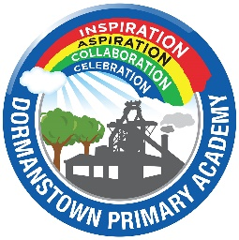
Dormanstown Primary Academy is a thriving learning community of 270 pupils aged 3-11. Our context is challenging, serving an area of socio-economic deprivation with high unemployment rates; a high proportion of our children are eligible for pupil premium. We have Local Authority commissioned High Needs base places for 40 pupils who come from across the Redcar & Cleveland Borough.
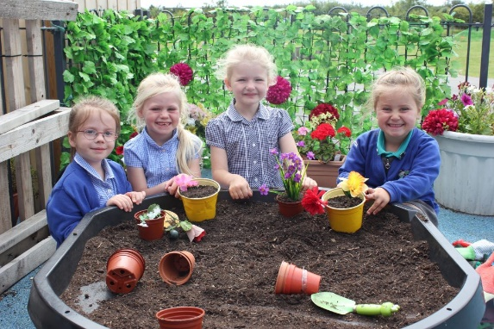
Our children are entitled to an excellent education; we ensure children have the essential knowledge, learning dispositions and key values to embrace the opportunities and challenges they encounter to go out into the world and make a difference to their own lives and that of others. We achieve this through expert teaching routed in cognitive science and underpinned by:
- A positive climate and routines for learning
- A well-sequenced, knowledge rich curriculum
- Planning for learning rather than performance
- Responsive teaching and effective feedback approaches
- Explicit teaching to extend and enrich vocabulary learning to address language development and the word gap
- A commitment to continual development by all staff
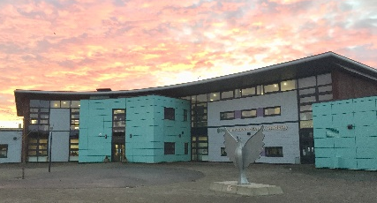
We have a shared understanding that ‘Learning is a persistent change in the long-term memory’. Using Trust plans as a starting point, teachers at Dormanstown plan clear sequences of learning which address and activate prior knowledge, introduce new knowledge in granular steps and make meaningful connections between old and new learning. This includes how to use spaced retrieval to ensure information is regularly revisited to enable the information to move from the working to the long term memory.
Our responsive teaching approach to feedback ensures we are constantly consulting and co-constructing learning with our pupils. Pupils are encouraged to be independent and teacher’s assessment for learning is pivotal in this process.
The recent relaunch of our school logo in collaboration with our whole community ensures our children display learning behaviours underpinned by our core values: ‘aspiration, inspiration, collaboration and celebration’, creating a nurturing environment that enables children to be successful learners.
Our children have excellent learning behaviours, are eager to learn and are supported by a team of hard-working and dedicated staff. The children of Dormanstown Primary are happy learners, who work hard to reach the challenges set by their teachers.
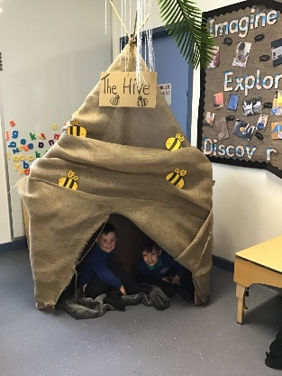
We work as part of Tees Valley Education, a Trust that has been operating since September 2015. We work very closely with our partner academies: Brambles, Pennyman, Wilton and Discovery. This gives us the opportunity to develop best practice and deliver improved outcomes for our children. It also allows us to ensure that all our staff receive high quality CPD to support them in achieving their professional goals.
Our vision for Dormanstown is ambitious, and presents a significant challenge, but we are already a long way into this journey. With inspirational pupils who share a love of learning, a passionate staff team and the resources of the TVEd Trust professionals, we ensure that our children set aspirational goals, inspire one another, collaborate and celebrate together.

